**Class:** Final Year (Computer Science and Engineering)

**Year:** 2022-23 **Semester:** 1

**Course:** High Performance Computing Lab

**Practical No. 4**

**Exam Seat No: 2019BTECS00064**

**Name – Kunal Santosh Kadam**

**Title of practical: Study and Implementation of Synchronization constructs**

**Problem Statement 1:**

Analyse and implement a Parallel code for below programs using OpenMP considering synchronization requirements. (Demonstrate the use of different clauses and constructs wherever applicable)

//Fibonacci Series using Dynamic Programming #include<stdio.h>

int fib(int n)

{

/* Declare an array to store Fibonacci numbers. */ int f[n+2]; // 1 extra to handle case, n = 0

int i;

/* 0th and 1st number of the series are 0 and 1*/ f[0] = 0;

f[1] = 1;

for (i = 2; i <= n; i++)

{

/* Add the previous 2 numbers in the series and store it */

f[i] = f[i-1] + f[i-2];

}

return f[n];

}

int main ()

{

int n = 9; printf("%d", fib(n)); getchar();

return 0;

}

**Screenshot #:**

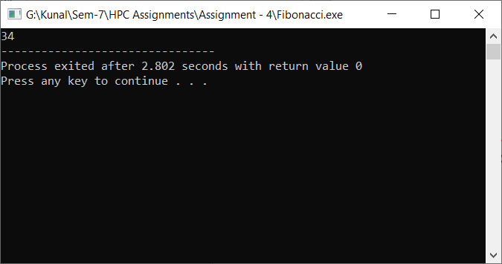

**Information #:**

**The following code is the recursive parallel code for the Fibonacci series. As there are some programs which can only be solved serially because more number of dependencies get involved to make them parallel which increases the overhead. So DP solution of Fibonacci problem is difficult to do in parallel**

In the below code, the parallel directive denotes a parallel region which will be executed by four threads. In the parallel construct, the single directive is used to indicate that only one of the threads will execute the print statement that calls fib(n).

The call to fib(n) generates two tasks, indicated by the task directive. One of the tasks computes fib(n-1) and the other computes fib(n-2), and the return values are added together to produce the value returned by fib(n). Each of the calls to fib(n-1) and fib(n-2) will in turn generate two tasks. Tasks will be recursively generated until the argument passed to fib() is less than 2.

The taskwait directive ensures that the two tasks generated in an invocation of fib() are completed (that is. the tasks compute i and j) before that invocation of fib() returns.

Note that although only one thread executes the single directive and hence the call to fib(n), all four threads will participate in executing the tasks generated.

Code:

//Fibonacci Series using Recursion

#include<stdio.h>

int fib(int n)

{

int i,j;

if(n<2)

return n;

else

{

#pragma omp task shared(i) firstprivate(n)

i = fib(n-1);

#pragma omp task shared(j) firstprivate(n)

j = fib(n-2);

#pragma omp taskwait

return i+j;

}

}

int main ()

{

int n = 9;

#pragma omp parallel shared(n)

{

#pragma omp single

printf("%d", fib(n));

}

// getchar();

return 0;

}

**Problem Statement 2:**

Analyse and implement a Parallel code for below programs using OpenMP considering synchronization requirements. (Demonstrate the use of different clauses and constructs wherever applicable)

// C program for the above approach

#include <stdio.h>

#include <stdlib.h>

// Initialize a mutex to 1

int mutex = 1;

// Number of full slots as 0

int full = 0;

// Number of empty slots as size

// of buffer

int empty = 10, x = 0;

// Function to produce an item and

// add it to the buffer

void producer()

{

// Decrease mutex value by 1

--mutex;

// Increase the number of full

// slots by 1

++full;

// Decrease the number of empty

// slots by 1

--empty;

// Item produced

x++;

printf("\nProducer produces" "item %d",x);

// Increase mutex value by 1

++mutex;

}

// Function to consume an item and

// remove it from buffer

void consumer()

{

// Decrease mutex value by 1

--mutex;

// Decrease the number of full

// slots by 1

--full;

// Increase the number of empty

// slots by 1

++empty;

printf("\nConsumer consumes " "item %d",x);

x--;

// Increase mutex value by 1

++mutex;

}

// Driver Code

int main()

{

int n, i;

printf("\n1. Press 1 for Producer" "\n2. Press 2 for Consumer" "\n3. Press 3 for Exit");

// Using '#pragma omp parallel for'

// can give wrong value due to

// synchronisation issues.

// 'critical' specifies that code is

// executed by only one thread at a

// time i.e., only one thread enters

// the critical section at a given time

#pragma omp critical

for (i = 1; i > 0; i++)

{

printf("\nEnter your choice:");

scanf("%d", &n);

// Switch Cases

switch (n)

{

case 1:

// If mutex is 1 and empty

// is non-zero, then it is

// possible to produce

if ((mutex == 1)&& (empty != 0))

{

producer();

}

// Otherwise, print buffer

// is full

else

{

printf("Buffer is full!");

}

break;

case 2:

// If mutex is 1 and full

// is non-zero, then it is

// possible to consume

if ((mutex == 1) && (full != 0))

{

consumer();

}

// Otherwise, print Buffer

// is empty

else

{

printf("Buffer is empty!");

}

break;

// Exit Condition

case 3:

exit(0);

break;

}

}

return 0;

}

**Information #:**

In producer consumer problem the producer generates the data and put in the buffer which is consumed by the consumer. This putting and taking of the data by producer and consumer is in parallel.

So, to do this we use the pragma omp file given by cpp predefined making the for loop parallel. But if we do this then there is a synchronisation issue and the data would go wrong. So to avoid this we have to synchronise the code which is common in them (i.e. the critical part)

In the above code we have used “#pragma omp critical” so the critical section works properly. This line ‘critical’ specifies that code is executed by only one thread at a time i.e., only one thread can enter the critical section at a time.

**Github Link:**

<https://github.com/Kunalkadam179/HPC-Assignment/tree/main/Assignment%20-%204>